**Student Questions**

Learn about the internals of a standard PC case by examining physical samples and selecting and labeling images found on-line. Gain deeper knowledge by researching and reporting on specific components.

PC Tower Case

1. Find one (or more) images that clearly show the internals of a PC Tower Case.   
   (i.e. Google images using keywords “PC Case Internals”)

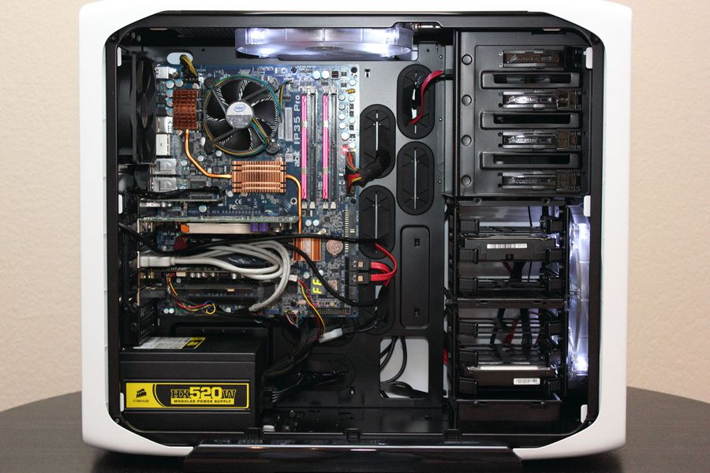

1. Clearly label the following components (using arrows) on your image of the PC case internals:
   1. Motherboard
   2. Power Supply
   3. Hard Disk Drive
   4. Optical Disk Drive (e.g.DVD)
   5. USB Expansion Ports
   6. Monitor Port
   7. Audio Ports
   8. Ethernet Port
   9. Cooling Fan



1. Research more in-depth about “Hard Disk Drives”. Make notes on the following:
   1. What different versions are currently available (speed and capacity)?

A modern Toshiba hard drive found on NEWEGG provides a rotational speed of 7200 RPM and can store 6Gb/s with a 128MB of cache.

* 1. How the capacity of the component has changed since the 1980’s

Compared to the prime hard disk drive, the IBM 305 RAMAC, it had just 350 disk storage and had no cache system.

PC Motherboard

1. Find one (or more) images that clearly show the layout of a PC Motherboard.   
   (i.e. Google images using keywords “PC Motherboard”)

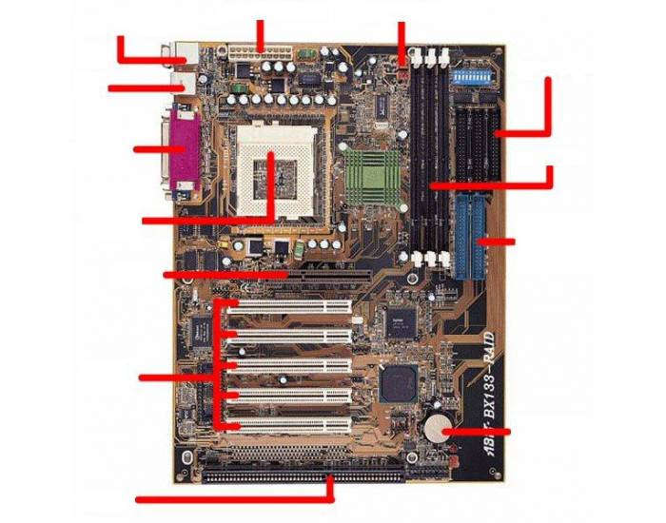

1. Clearly label the following components (using arrows) on your image of the PC motherboard:
   1. CPU (and fan)
   2. RAM Memory
   3. Disk Drive Interface (IDE or SATA)
   4. GPU Graphics Processor (either on-board or Graphics Card)
   5. Sound Processor (either on-board or Sound Card)
   6. Wi-Fi / Ethernet Network Interface (either on-board or Graphics Card)

1. Research more in-depth about “CPU Processor Chip”. Make notes on the following:
2. What different versions are currently available (speed and capacity)?

Intel 4004’s microprocessor from the 1970s has 2 300 transistors, a 640 byte memory, a 4-bit memory path, and had the speed to process 60 000 operations per second (OPS). The Intel 4004 had a cost of $200. Compared to a modern processor, in this case the Intel Pentium g4560, it has an astounding 740 kHz of clock speed, has 64Gb of memory and costs about $64.

1. How the speed of the component has changed since the 1980’s

As I have already written, the speed of the component has increased drastically, this is of course in terms of memory, and clock speed.

Peripheral Devices

1. Find one (or more) images that clearly show the layout of the back of a typical PC tower case.   
   (i.e. Google images using keywords “Back Of PC Tower”)  
   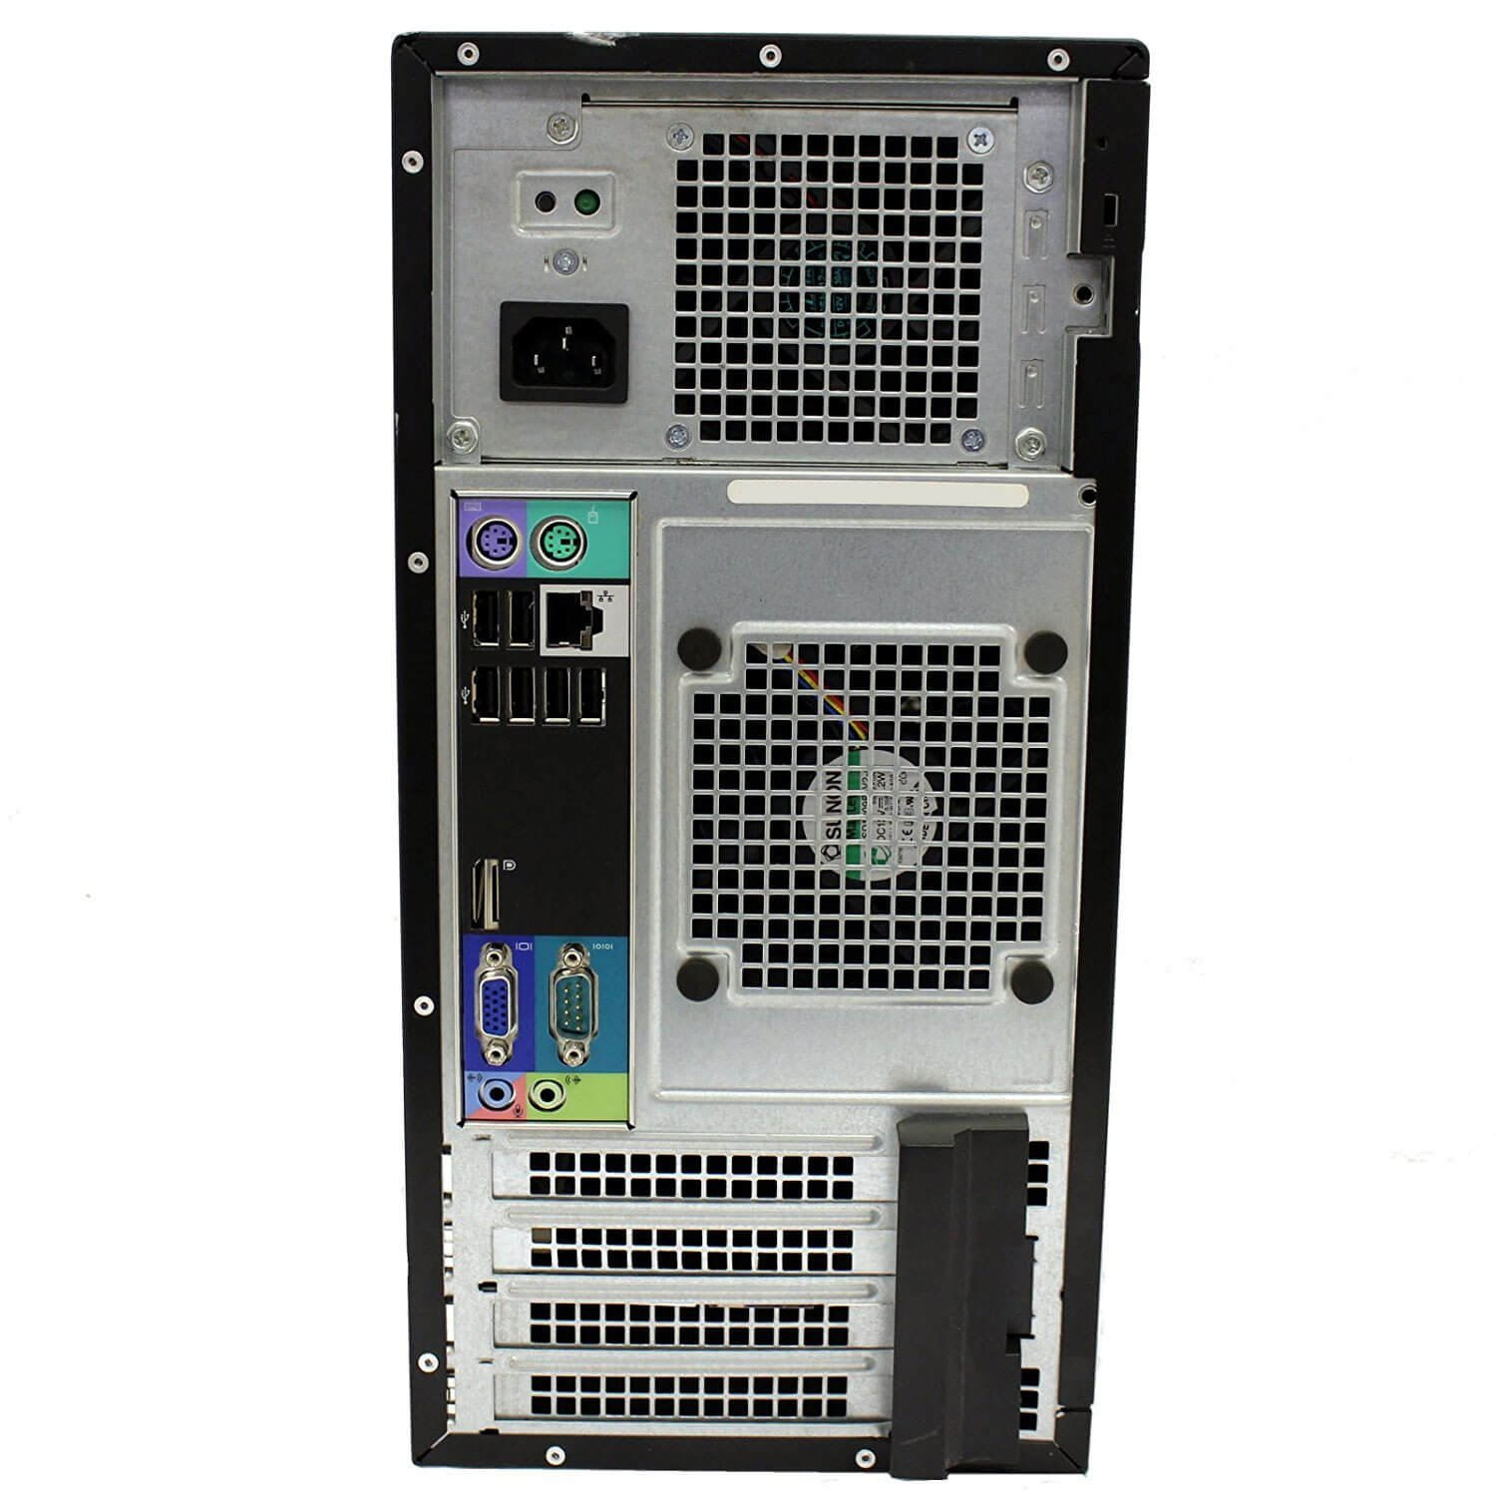
2. Clearly label the following components (using arrows) on your image of the back of a typical PC tower case:
   1. Power cord and power switch
   2. Monitor Interface (VGA or DVI or HDMI)
   3. Mouse Interface (USB or PS/2)
   4. Keyboard Interface (USB or PS/2)
   5. USB Ports
   6. Audio Inputs / Outputs
   7. Ethernet Interface

1. Research more in-depth about “External Portable Storage”. Make notes on the following:
2. Floppy Disks

Floppy disks are a kind of portable storage system for computers, consisting of thin magnetic disks, data is written on to the disk using something called a floppy disk drive.

1. CD-ROM / DVD / Recordable CD/DVD

A CD ROM is a compact disk standing on a read only memory system, where data is written on a disk and read on the computer drive, in its case, the CD ROM can not be altered by a simple drive.

1. USB Memory Drives

Stands for integrated Universal Serial Bus interface, the USB collects and stores data without the need for a power source and is small and can carry large pieces of information.

1. Compact Flash Memory

Compact flash memory is a method of memory storage, where data is placed in a small card like chip, today the flash memory card is used for digital photos and higher quality video cameras.

1. Cloud Based Storage

Cloud based storage is where data is stored on isolated links and they are maintained, and managed everywhere by a service entity, and can be accessed at any time.

**Presentation Outline**

Explore the development and features of a specific PC hardware component through deeper research and investigation. Work in partners to create a short presentation. Deliver the presentation to the class.

Each group will research a unique PC hardware component. Your specific topic will be assigned from the list provided below.

**Presentation Structure**

1. Explain what the PC component does and how it fits together with other components to make up a fully functioning PC.
2. Explain how the PC component works. Provide a diagram (image) showing the main parts of the component.
3. Research the current state of the art of the component in terms speed, capacity (size), and other related factors.
4. Research on-line suppliers that sell the PC Component. List the specifications for the available products and the cost (price).
5. Research how the PC component has changed and evolved since the early days of PCs in the 1980’s. Cover each of the following topics separately:
   1. Component Speed
   2. Component Size / Capacity
   3. Two other specifications specific to the PC component (ask Mr. Nestor)

**PC Component Topics**

|  |  |  |
| --- | --- | --- |
| **Topic** | **Partner 1** | **Partner 2** |
| CPU Microprocessor Chip | Anser | Harjas |
| Motherboard Layout |  |  |
| Computer Graphics |  |  |
| Sound & Audio |  |  |
| Hard Disk Drives |  |  |
| Removable Disk Storage |  |  |
| Ethernet / Fiber Connectivity |  |  |
| WIFI / Bluetooth Connectivity |  |  |
| Mouse / Pointing Devices |  |  |
| Monitor & Display Technology |  |  |
| Printers & Output Technology |  |  |